

Newsletter Vol.3

WINTER 2023

WHAT WE DO: We are a service for everyone in the Cessnock LGA:- if you need a hand with a free meal, support, a listening ear and referrals to other services who may be of assistance to you**.** We are local in the Cessnock LGA and here to help.

Email Secretary: psbstrickland@bigpond.com

<https://www.facebook.com/groups/SoupzOn>



[This Photo](https://www.pngall.com/ban-png/) by Unknown Author is licensed under [CC BY-NC](https://creativecommons.org/licenses/by-nc/3.0/)

**!!**

We help!

Soupzon Through Grace Inc. is a charity which supports our community. That means anyone who needs a hand up.

We are pretty practical about it. When you come to our meals service you will be offered a free meal (including a take away if you would like), a seat at the table and conversation from people who will welcome you as a mate

**What we don’t do:**

Sadly we are not equipped or licensed to provide accommodation

Meet Ramon – a volunteer chef with amazing credentials… and a big heart.

Thank you Ramon! Ramon is originally from Brazil and Italian dishes are among his favourites. He still raises an eyebrow about why so many of us appreciate pineapple on our pizza!

ABN 33 942 189 392

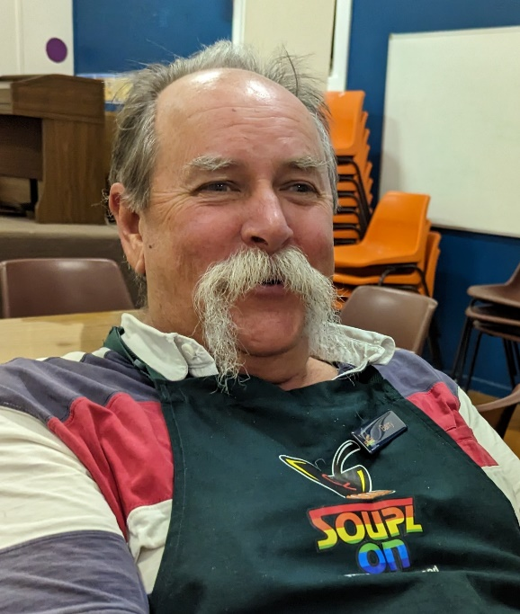

**THE KITCHEN IS OPEN**

WHEN:

Mondays and Wednesdays,

5.00pm to 8.00pm

WHERE:

Baptist Church Hall, Cnr. Cooper and King Streets, Cessnock.

**and**

WHEN: Fridays and Saturdays, from 7.00pm

WHERE: TAFE Park, Cessnock**.**

**and**

WHEN: Sunday fortnightly in partnership with the Abermain Mission Hall Church 5.00pm-7.00pm

WHERE: 139 Harle Street, Abermain

**Watch for confirmations on our facebook page:**

**The next dates for winter are:**

**Sunday 13th August**

**Sunday 27th August**

Meet Barry. By day he is a Bio Security Specialist. He is also a talented creator of treats such as muffins, rocky road, and scones.

We love his cheek. He describes himself as “politically incorrect” but we see a generosity of spirit and a ready laugh. He is a highly valued volunteer. Thank you Barry!

**Thank you Cessnock Leagues Club:**

**We have been inundated**

**with donated goods and want to give them away!**

You will very soon see our new trailer on the road in the Cessnock region. We are taking to the road to give out donated goods. We have received very generous donations of clothing, hygiene packs, Manchester, small household items, and emergency groceries.

Please keep an eye out on our facebook page to see when we will be in your area. The service is due to begin within 2 weeks!!

https://www.facebook.com/groups/SoupzOn

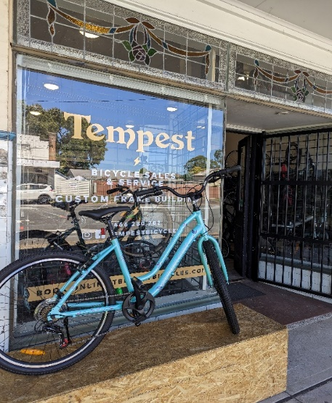

Thank you Rob of Tempest Bicycles, Weston

Thank you so much for your support Ruth, and Ms D…

If you have donated or volunteered your time recently, we are sincerely grateful. Your help keeps the service running.

We welcome new volunteers to our service. If you are interested in getting involved please check us out during meals service. Have a look at what we do hands on and chat with Rosie, Wayne and the crew to find out how you may help and what we would expect from you.

QUESTIONS? Catch us on facebook: https://www.facebook.com/groups/SoupzOn

Wayne’s scrambled eggs and ham



**Remember our recent introduction of the use of a coffee van?**

We are still working on a few maintenance issues –

we want the coffee van to be brilliant and so it’s introduction to our service has been slightly delayed.

It should be on the road by Spring!