Newsletter Vol.1
SUMMER 2023
Soupzon Through Grace Inc.
139 Harle Street, ABERMAIN, NSW. 2326
Sue Strickland -Secretary/ Treasurer
Email: psbstrickland@bigpond.com
https://www.facebook.com/groups/SoupzOn

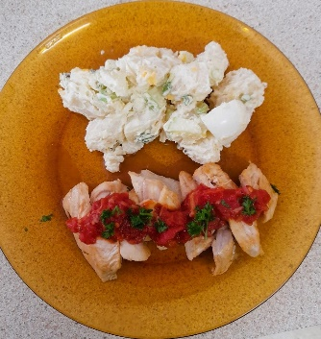
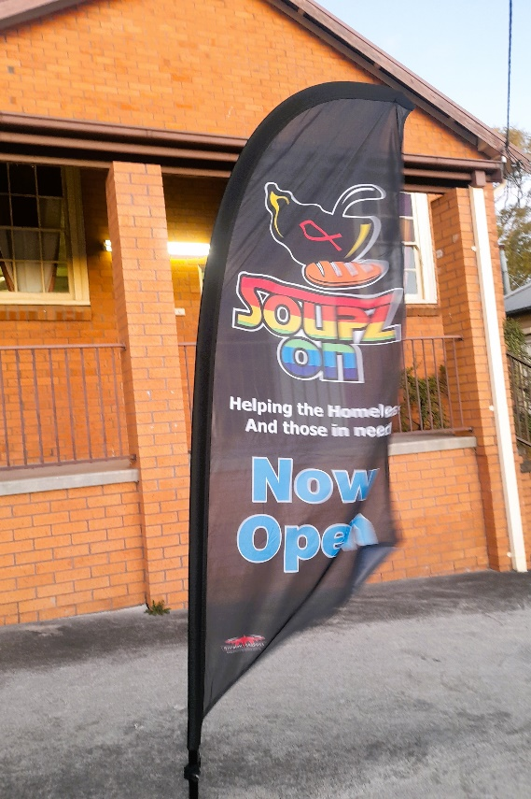
It’s a service for everyone finding it tough to manage today and tomorrow. It’s local to the Cessnock LGA and for the community.

What we don’t do
We are not equipped to supply accommodation
Who we are and what we do
We are a service for everyone:- homeless, finding it tough or needing a hand with a free meal, support, a listening ear and referrals to other services who may be of assistance to you.
We are here to help; firstly with a free meal: that is what we do!
About donations of money and goods:
We are not government funded and rely upon donations.
We gratefully accept monetary donations. We are a charity and registered as a public benevolent incorporated association.
Donations of money are tax deductible.
Please contact me with enquiries and for bank details: Sue Strickland -Secretary/ Treasurer Email: psbstrickland@bigpond.com
We give out non cash donations as soon as possible once received to those who need them.
Butterflied pan fried chicken with Napoli sauce and potato salad – thank you Chef!
A sample of the food
THE KITCHEN IS OPEN
WHEN:
Mondays and Wednesdays,
5.00pm to 8.00pm
WHERE:
Baptist Church Hall, Cnr. Cooper and King Streets, Cessnock.
and
WHEN:
Fridays and Saturdays, from 7.00pm
WHERE:
TAFE Park, Cessnock.
JUST LOOK FOR THE BANNERS
YOU ARE WELCOME!
WELCOME TO THIS, OUR FIRST NEWSLETTER. YOU MAY ALREADY KNOW WE ALSO HAVE A FACEBOOK PAGE SO THAT WE ARE READILY CONTACTABLE.
The newsletter is intended to share what is happening and services available from us, as well as events coming up.
Please join us for news of the ongoing journey and growth of SOUPZON THROUGH GRACE INC.
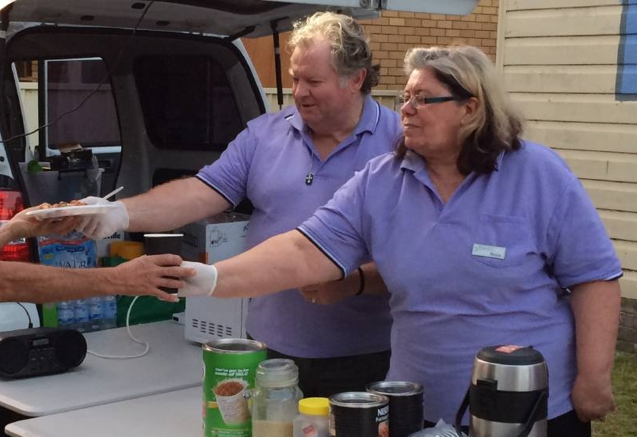
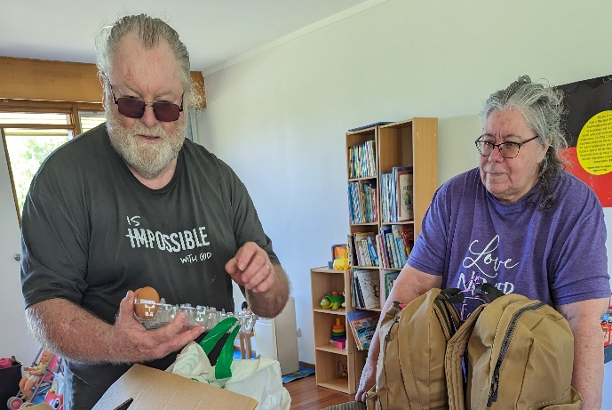
Founders, Rosie and Wayne
Rosie and Wayne
at work
We are a team of volunteers.
We also welcome new volunteers to our service. If you are interested in getting involved please check us out during meals service (details on the previous page). Have a look at what we do hands on and chat with Rosie and Wayne to find out how you may help and what we would expect from you.

Soupzon Through Grace Inc. is a charity which supports the vulnerable in our community. That means anyone who needs a hand up and is doing it tough; whether homeless, financially struggling or in need.
We are pretty practical about it. When you come to our meals service you will be offered a free meal (including a take away if you would like), a seat at the table and conversation from people who will welcome you.
As a secondary service we provide related support such as donated clothing, emergency food, hygiene and care hampers according to need.

We also refer to other charities and supportive entities within our community network who can provide specialist professional services.
Our service is run by locals, for locals.

Our team of volunteers
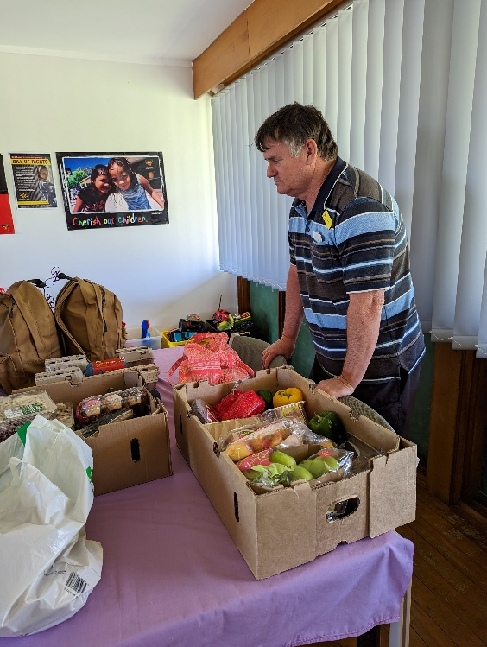
What’s on
Shine for Kids, Cessnock
Who support, advocate and mentor children and young people who are affect by a parent’s imprisonment.
We have been honoured to reconnect with Dave and Shine for Kids at Cessnock.
It’s tough for families to travel, accommodate and provide meals during visits of family members who are imprisoned, often many kilometres away from the family home.
In addition to coping with the separation of family members it can cause financial difficulties as a consequence of being away from home.
We are now providing a weekly delivery of emergency groceries and hygiene packs, along with additional goods as needed to assist visiting parents to get through the following week after visits.

Pictured: Dave and some of last week’s delivery of donated goods

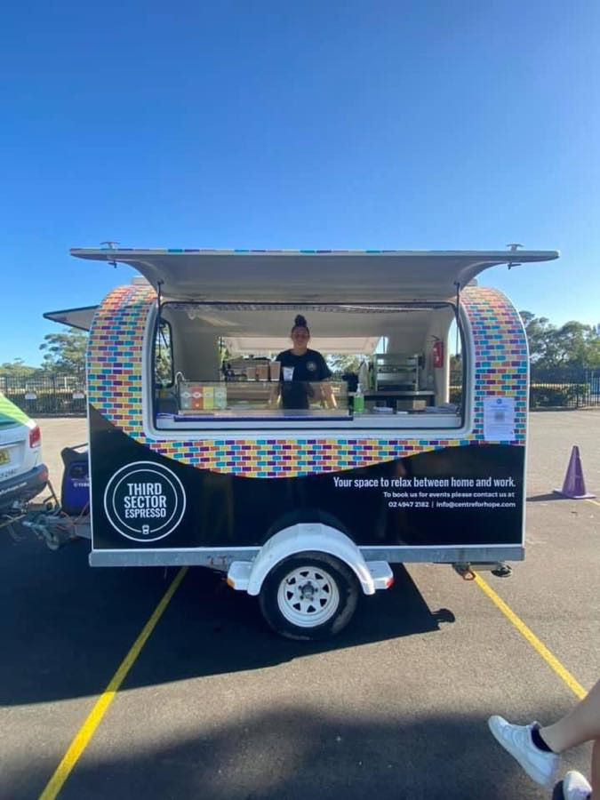
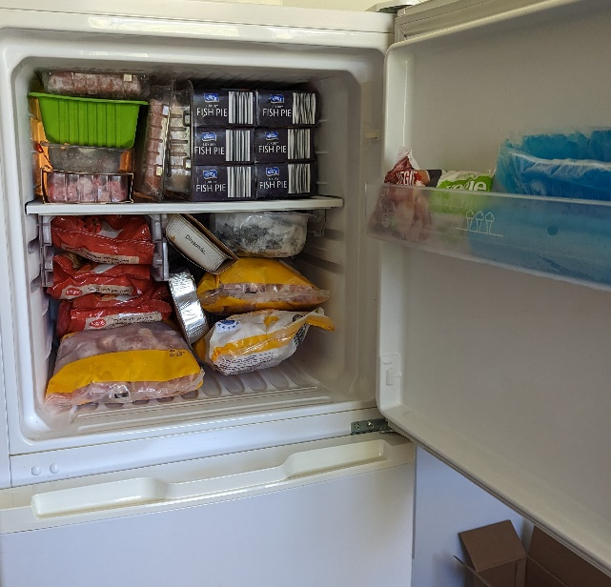
Coming soon…
We have been given the use of a fully equipped Coffee Cart and we are very excited about it!
Keep an eye out for it in the next few weeks during meals service at the rotunda at TAFE Park Cessnock on Fridays and Saturdays from 7.00pm.

Soupzon Through Grace Inc.
139 Harle Street,
ABERMAIN, NSW 2326
ABN. 33 942 189 392
https://www.facebook.com/groups/SoupzOn

Mission Statement - Purpose
THE DETAILS:
To provide nutritious meals in a safe environment,
currently operating 4 nights per week in the Cessnock LGA.
To respond to individual and family needs, providing assistance and services to vulnerable persons in the community.
The Association addresses the basic human hierarchy of needs in a most inclusive and practical way.
The Association will continue to seek further opportunities to grow the service to better meet a growing community demand.
.
Provision of Supporting Services
The Association adopts a wholistic and flexible approach, utilising resources available at any time to provide additional services according to need:
*emergency hampers of food, clothing, toiletries and household goods on a needs basis
*services to Shine for Kids Co-operative at Cessnock
*providing referral information, pastoral care and hands on practical assistance
*household goods as available to those where longer term housing has been secured
*links to professionals who donate health and hygiene services
*referrals to counselling, addiction and mental health services
*administration support related to Centrelink services, housing and job applications.

Community networks
The Association works with local businesses and charities who supply goods and services which address the needs of the client group for food, clothing and professional services.
Volunteer team
All volunteers receive training suitable for the services provided and are enabled to refer clients to partnered community specialist services.
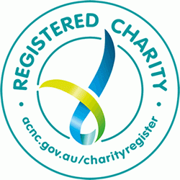
All office bearers, committee and members are volunteers, endorsed with police and working with children checks.

