Soupzon Through Grace Inc. is a charity which supports our community. That means anyone who needs a hand up.
We are pretty practical about it. When you come to our meals service you will be offered a free meal (including a take away if you would like), a seat at the table and conversation from people who will welcome you as a mate

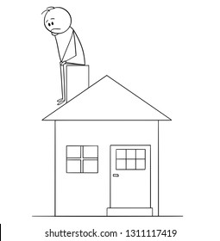

What we don’t do:
Sadly we are not equipped
or licensed to
provide accommodation

WHAT WE DO: We are a service for everyone in the Cessnock LGA:- if you need a hand with a free meal, support, a listening ear and referrals to other services who may be of assistance to you, we are here for you. We are local in the Cessnock LGA.
Email Secretary: psbstrickland@bigpond.com
https://www.facebook.com/groups/SoupzOn

ITS SPRING!!
MAY YOUR SUN COME OUT
Just look for the flags and we’ll be there!
About donations of money and goods:
We are not government funded and rely upon donations.
We gratefully accept monetary donations. We are a charity and registered as a public benevolent incorporated association.
Donations of money are tax deductible.
Please contact me with enquiries and for bank details: Sue Strickland -Secretary/ Treasurer Email: psbstrickland@bigpond.com
We give out non cash donations as soon as possible once received to those who need them.

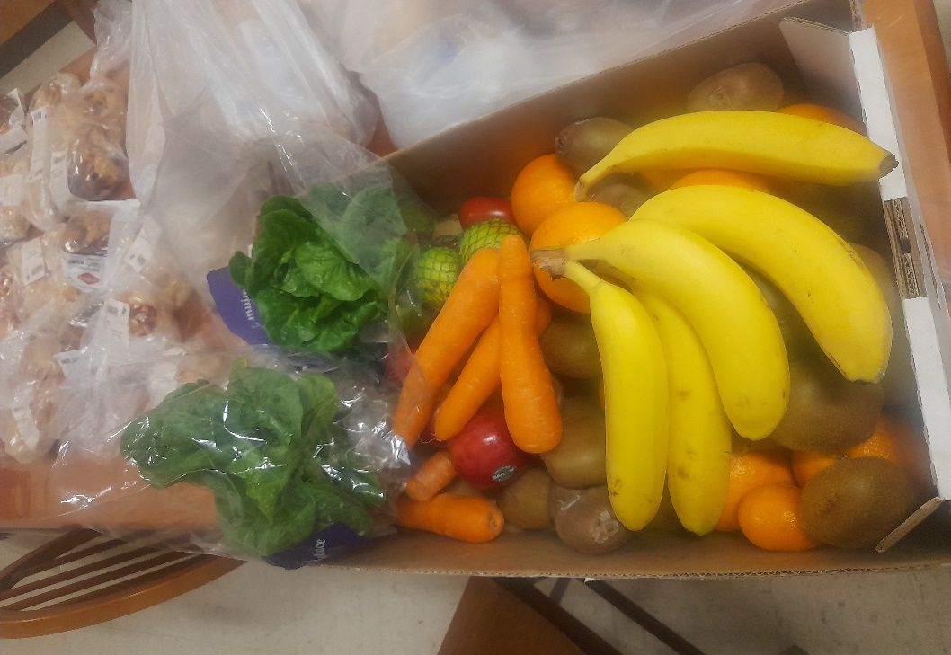
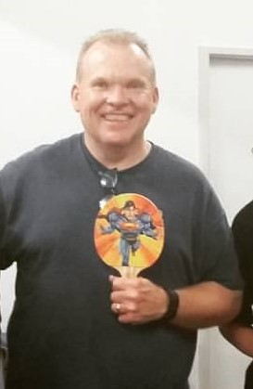
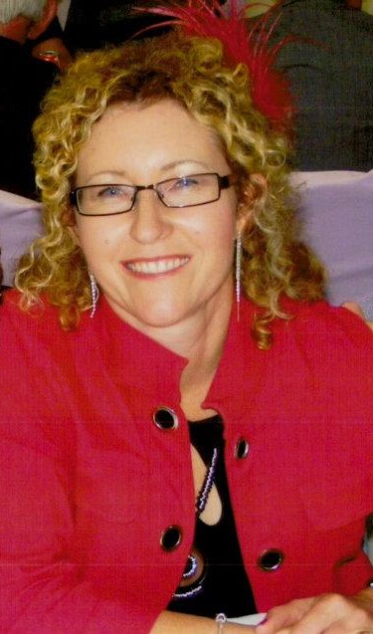
THE KITCHEN IS OPEN
WHEN:
Mondays and Wednesdays,
5.00pm to 8.00pm
WHERE:
Baptist Church Hall, Cnr. Cooper and King Streets, Cessnock.
and
WHEN:
Fridays and Saturdays, from 7.00pm
WHERE:
TAFE Park, Cessnock.
and
WHEN:
Fortnightly Sunday 5.00-7.00pm
WHERE:
Abermain Mission Hall Church hall, 139 Harle Street, Abermain.
NEXT one is Sunday 22nd October
Thank you Minifarms Cessnock – your fresh produce is fabulous!
Ruth Mitchell, Fresh Buys Cessnock for Minifarms Australia
minifarmscessnock@iinet.net.au
Meet Lisa and Brian Procter.
VOLUNTEERS
They donate time, energy, their (significant) brains trust, to Soupzon Through Grace Inc. as members of the committee, in addition to the Abermain Mission Hall Church and other causes as well.
Lisa is a chemical engineer. Brian is a primary school teacher. They are both so valuable to us – fun too!
Thank you guys so much:

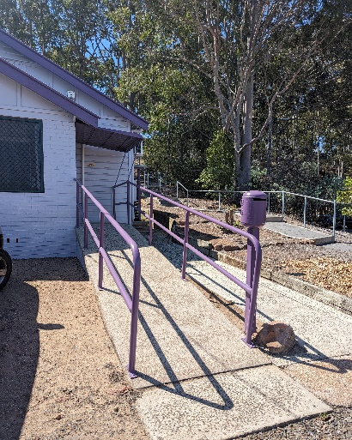
This is such a needed service…look for THE PURPLE PLACE! Its at 6 Cumberland Street, Cessnock. Signs will be up soon.
Just text to request an appointment to wash your clothes. Details are undernoted. Thank you Spirit of Giving Fundraising Hub Inc.

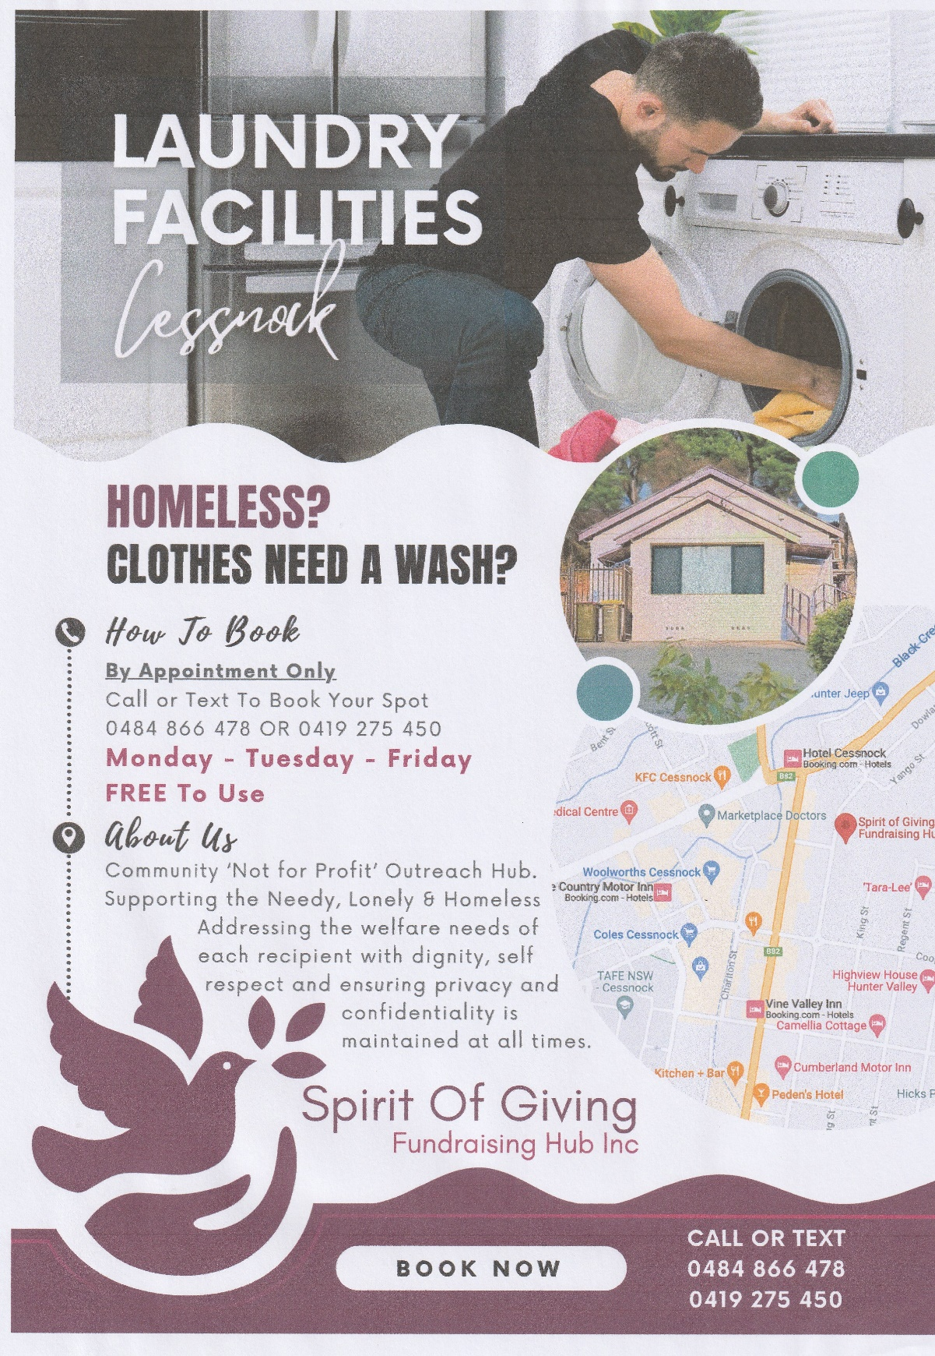

Soupzon Through Grace Inc.
139 Harle Street,
ABERMAIN, NSW 2326
ABN. 33 942 189 392
https://www.facebook.com/groups/SoupzOn

Mission Statement - Purpose
THE DETAILS:
To provide nutritious meals in a safe environment,
currently operating 4 nights per week in the Cessnock LGA.
To respond to individual and family needs, providing assistance and services to vulnerable persons in the community.
The Association addresses the basic human hierarchy of needs in a most inclusive and practical way.
The Association will continue to seek further opportunities to grow the service to better meet a growing community demand.
.
Provision of Supporting Services
The Association adopts a wholistic and flexible approach, utilising resources available at any time to provide additional services according to need:
*emergency hampers of food, clothing, toiletries and household goods on a needs basis
*services to Shine for Kids Co-operative at Cessnock
*providing referral information, pastoral care and hands on practical assistance
*household goods as available to those where longer term housing has been secured
*links to professionals who donate health and hygiene services
*referrals to counselling, addiction and mental health services
*administration support related to Centrelink services, housing and job applications.

Community networks
The Association works with local businesses and charities who supply goods and services which address the needs of the client group for food, clothing and professional services.
We are a team of volunteers.
We also welcome new volunteers to our service. If you are interested in getting involved please check us out during meals service (details on the previous page). Have a look at what we do hands on and chat with Rosie, Wayne and Brian to find out how you may help and what we would expect from you.

