Soupzon Through Grace Inc.
139 Harle Street, ABERMAIN, NSW. 2326
Sue Strickland -Secretary/ Treasurer
Email: psbstrickland@bigpond.com
https://www.facebook.com/groups/SoupzOn

Newsletter Vol.2
AUTUMN 2023
Who we are and what we do

This Photo by Unknown Author is licensed under CC BY-NC
What we don’t do:
Sadly we are not equipped or licensed to provide accommodation.
Soupzon Through Grace Inc. is a charity which supports our community. That means anyone who needs a hand up.
We are pretty practical about it. When you come to our meals service you will be offered a free meal (including a take away if you would like), a seat at the table and conversation from people who will welcome you as a mate

About donations of money and goods: We are not government funded and rely upon donations.
We gratefully accept monetary donations. We are a charity and registered as a public benevolent incorporated association.
Donations of money are tax deductible. Please contact me with enquiries and for bank details: Sue Strickland -Secretary/ Treasurer Email: psbstrickland@bigpond.com
We give out non cash donations as soon as possible once received to those who need them.
We welcome new volunteers to our service. If you are interested in getting involved please check us out during meals service. Have a look at what we do hands on and chat with Rosie and Wayne to find out how you may help and what we would expect from you.

THE KITCHEN IS OPEN
WHEN:
Mondays and Wednesdays,
5.00pm to 8.00pm
WHERE:
Baptist Church Hall, Cnr. Cooper and King Streets, Cessnock.
and
WHEN:
Fridays and Saturdays, from 7.00pm
WHERE:
TAFE Park, Cessnock.
LOOK FOR THE BANNERS
YOU ARE WELCOME!
What we do -

We are a service for everyone in the Cessnock LGA:- if you need a hand with a free meal, support, a listening ear and referrals to other services who may be of assistance to you.
We are local and here to help.

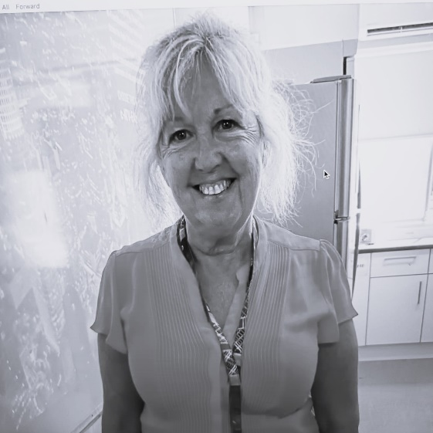
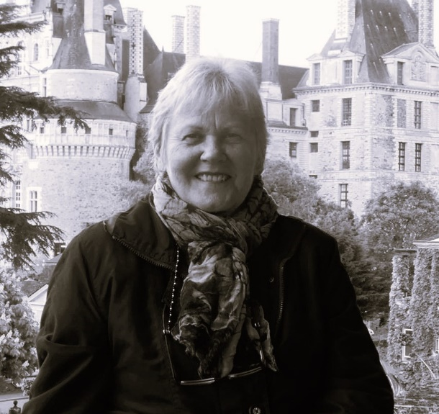

Debbie Boehme
Debbie Barry
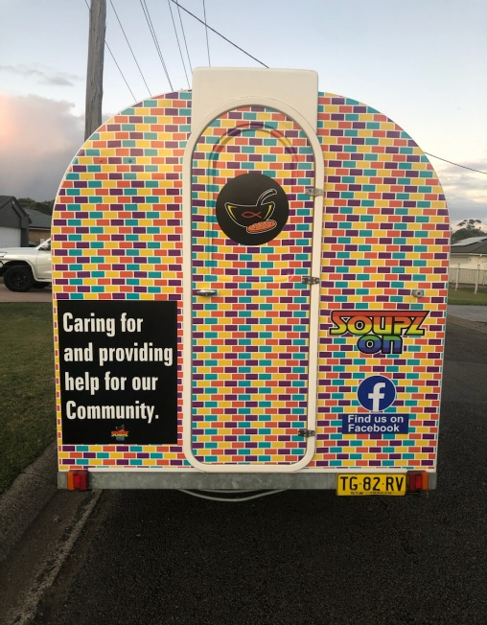
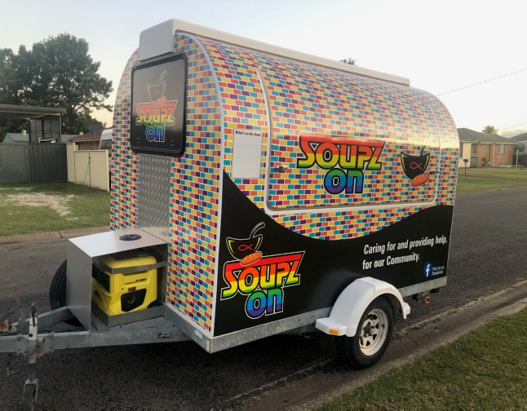
NEWS – the latest!
We are thrilled to have the opportunity to use a coffee van with all the facilities on board, on loan.
Thank you so much for this chance our beloved donor – we will take good care of it.
Keep an eye out on the road for the coffee van which will be introduced to our service in the very near future. It’s bright and cheerful and easy to spot!
How much better will it be to be able to serve food and drinks from such a van – especially with the winter coming.

NEWS – coming up in the lift!
It’s been hard to include all our donated goods ready for display and distribution so we are in the process of coming up with something better – watch this space.

Meet some of our team: they bring so many skills with them and big hearts as well.
Our membership and committee are all volunteers with so many skills to offer between them. We now feature Debbie Barry (retired nurse and midwife who now volunteers for others as well as Soupzon Through Grace Inc.) and Debbie Boehme (social worker, counsellor and specialist financial counsellor) who works locally as well as volunteering her time for Soupzon. They are both champions and part of our brains trust. Thank you so much ladies.
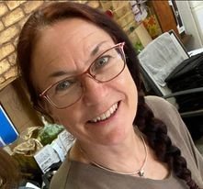

Donor profile
You may have met Ruth from Minifarms Cessnock already. She has been quietly helping us (and others) by donating fresh produce as well as passing along home cooked donated goods from her customers. She was also the major co-ordinator for the Reverse Advent boxes from last Christmas. Good on you Ruth and thank you heaps. Your fresh produce is amazing.
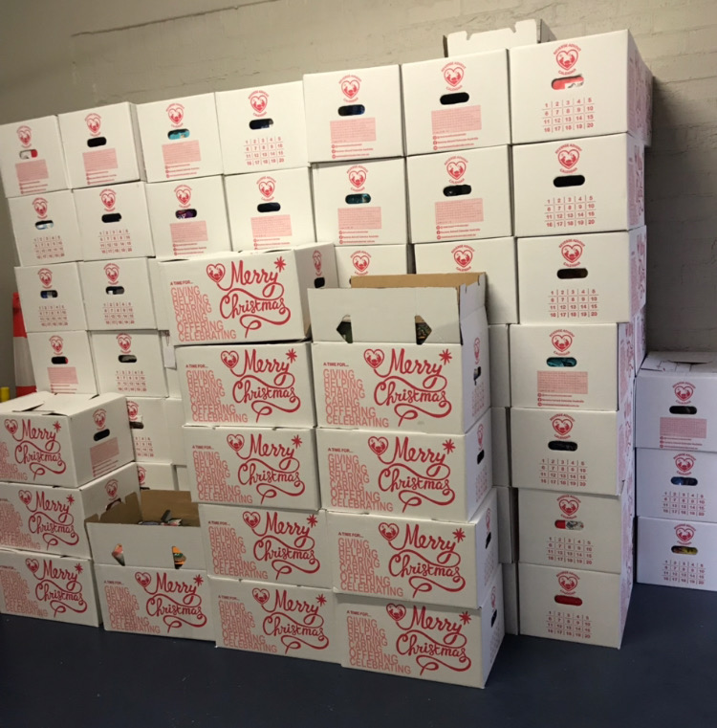
Reverse Advent boxes given out full of goodies to so many last Christmas – organised by Ruth of Minifarms Cessnock
Soupzon were able to give out so many at a financially challenging time.
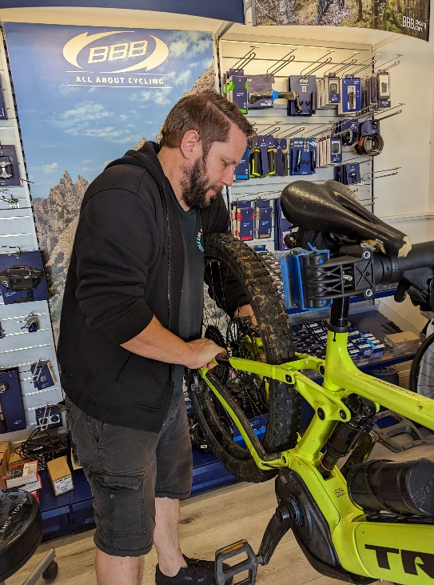
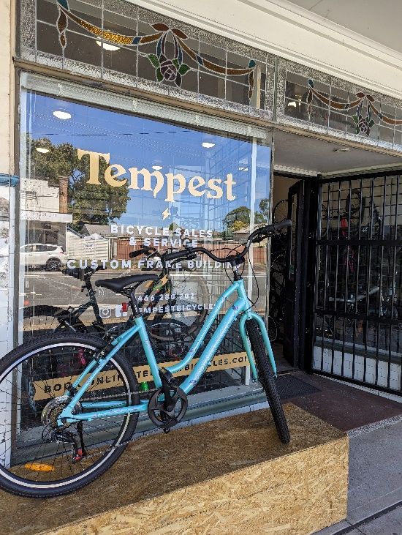
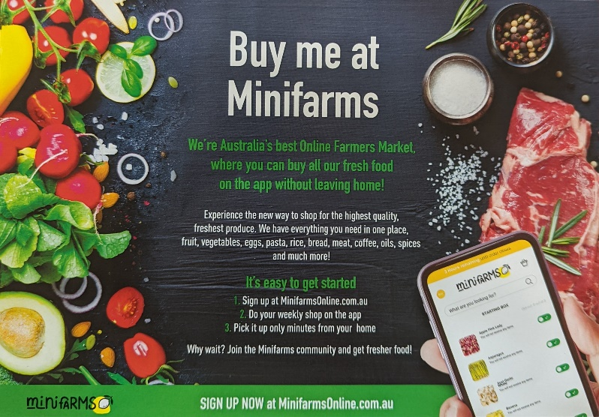
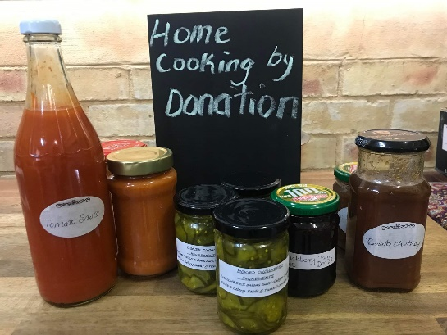
A huge thank you to Rob of Tempest Bicycles, Weston.
We were recently able to work with a local school to arrange a free bike give away of 6 bikes to kids without a bike on “Ride to school” day.
Rob went over the bikes with a fine tooth comb and make sure they were serviced and safe. Thank you so much Rob.

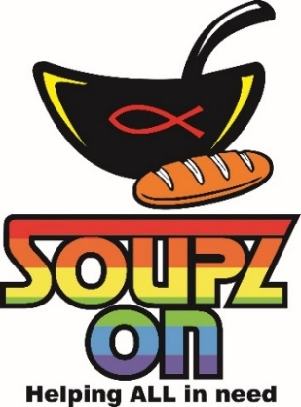
Soupzon Through Grace Inc.
139 Harle Street, ABERMAIN, NSW 2326
ABN. 33 942 189 392
https://www.facebook.com/groups/SoupzOn

Soupzon Through Grace Inc.
THE DETAILS:
Mission Statement -
To provide nutritious meals in a safe environment,
currently operating 4 nights per week in the
Cessnock LGA.
To respond to individual and family needs, providing assistance and services to
vulnerable persons in the community.
The Association addresses the basic human hierarchy of needs in a most inclusive and practical way.
The Association will continue to seek further opportunities to grow the service to better meet a growing community demand.

Provision of Supporting Services
The Association adopts a wholistic and flexible approach, utilising resources available at any time to provide additional services according to need:
*emergency hampers of food, clothing, toiletries and household goods on an as needs basis
*services to Shine for Kids Co-operative at Cessnock
*providing referral information, pastoral care and hands on practical assistance
*household goods as available to those where longer term housing has been secured
*links to professionals who donate health and hygiene services
*referrals to counselling, addiction and mental health services
*administration support related to Centrelink services, housing and job applications.

We are all volunteers.
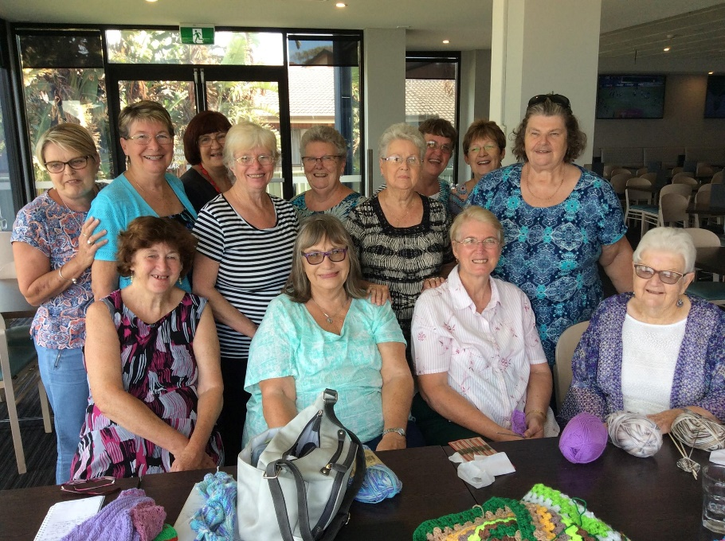
Thank you ladies, so much

FEATURE:
The Guardian Angels/ Wild Woollies Group
Finally, we must tip our hat with huge thanks to the Guardian Angels/ Wild Woollies group who have donated beautiful (and warm) hand made woollen items. With winter coming up we are especially grateful to be able to give them out to those who need them.
The creation of GUARDIAN ANGELS/ WILD WOOLIES
Wild Woolies was started by the then Librarian at Lake Haven Library nearly 12 years ago in the lead up to the ABC Big Knit In for Wraps With Love. We made blankets for them for some time and eventually expanded to making and donating a variety of items to many other places, including local Neighbourhood Centres. Guardian Pharmacy for over 20 years ran a program whereby for a few months each year they received knitted and crocheted items to be donated to various charitable organisations. The Guardian Pharmacist at Gorokan is very community minded and hosted a Thank You Morning Tea each year. In 2014 he said that he wanted the program to run year round and so Guardian Angels was born. The two groups meet in different locations but are joined together on Facebook, with several members joining together in meetings of both groups. We have continued to grow over the years and expand on what we make and who receives our creations. Linda Kebblewhite is one of our long term members and , when needed last year, located SoupZon and other places more local to her, to whom we could donate. Our crafters make a variety of items, blankets both knitted and crocheted, jumpers, cardigans, beanies, baby items, toys, Trauma Teddies, twiddle muffs and mats and more. We enjoy helping others in our communities and responding to specific requests where we can.
